Индивидуальные трансферы из а/п ОЛБИЯ (в одну сторону)

DESTINATION

CAR
1/4 PAX
MINIVA
N
5/8 PAX
Olbia città 32 44
Capo Ceraso-Pittulongu-Porto San Paolo-Porto Istana-Costa Dorata- Murta Maria 40 105
G. Aranci-Porto Rotondo-Golfo di Cugnana-Golfo di Marinella-San Pantaleo 53 74
San Teodoro-Puntaldia-Porto Coda Cavallo 59 80
Baja Sardinia-Porto Cervo-Arzachena-Cannigione 66 93
Palau-Porto Raphael-Costa Serena 80 114
Budoni-Agrustos-Porto Ottiolu 66 93
La Caletta-Siniscola 80 114
Santa Teresa Gallura 112 155
Badesi-Valledoria-Isola Rossa-Vignola-Aglientu 139 162
Costa Paradiso 167 189
Orosei-Cala Ginepro 125 168
Cala Gonone, Oliena 141 189
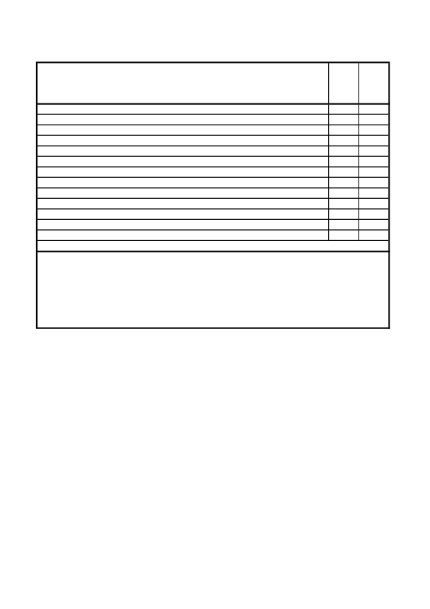
Night service supplement: + 10% from 10:01pm to 12.00pm and from 06:00 to 07:59 am; + 30% from 00:01pm to 05:59 am (supplements apply based on the actual time of departure from the hotel/residence). Transfer from the port of Golfo Aranci: supplement of € 32 hotels in south and northwest; surcharge of € 7 hotels in north.
Baby seats for infants: € 5 on request, to be paid on spot
Incoming and outgoing transfers to San Teodoro apartments and residences are only made to the reception office of the local correspondent.

